DOWNLOAD MAVEN

http://maven.apache.org/download.cgi
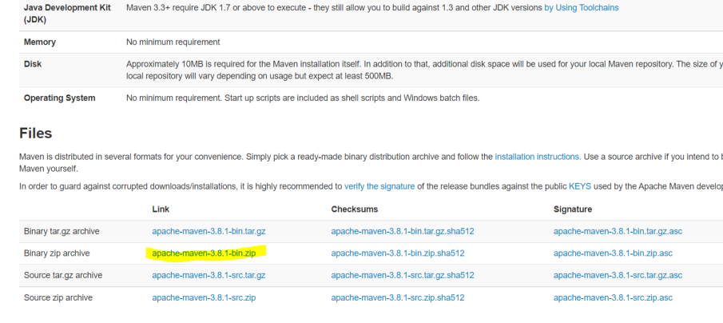

Unzip it to a folder. Eg: C:\apache-maven-3.8.1
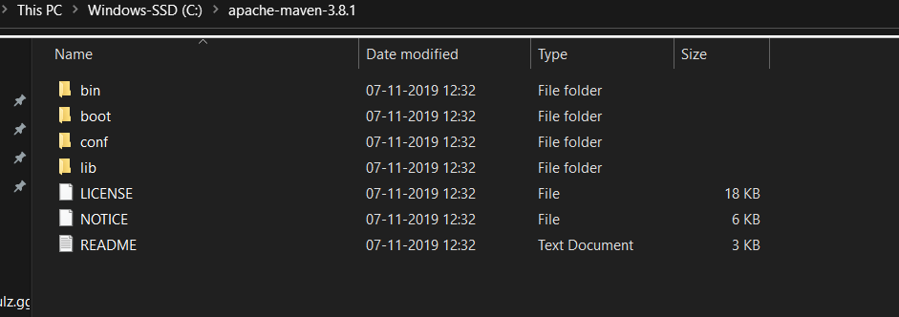

Add MAVEN_HOME system variable

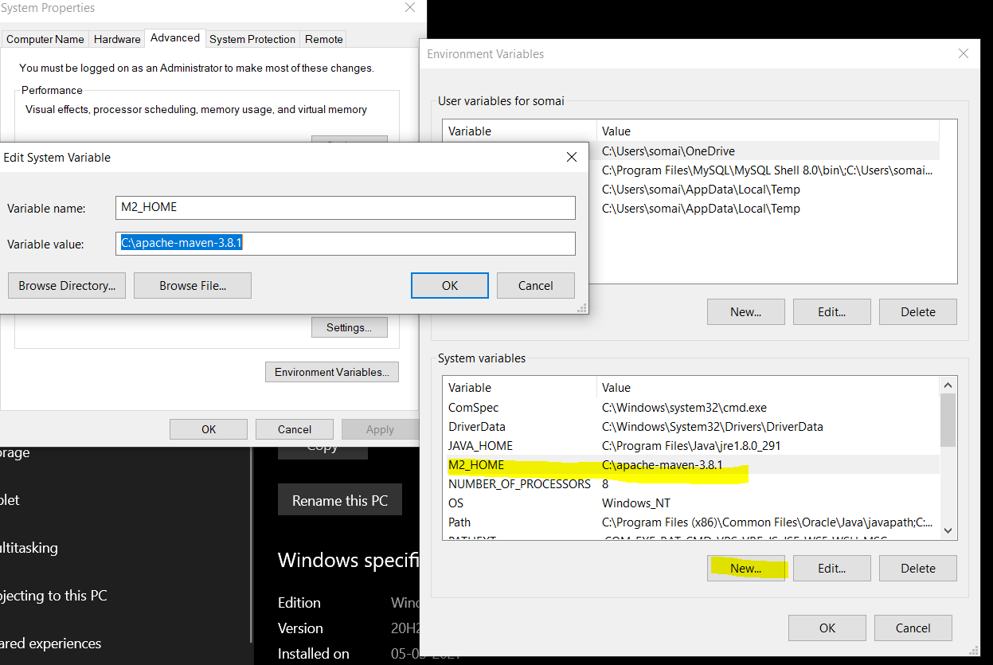

Add Maven bin to path variable
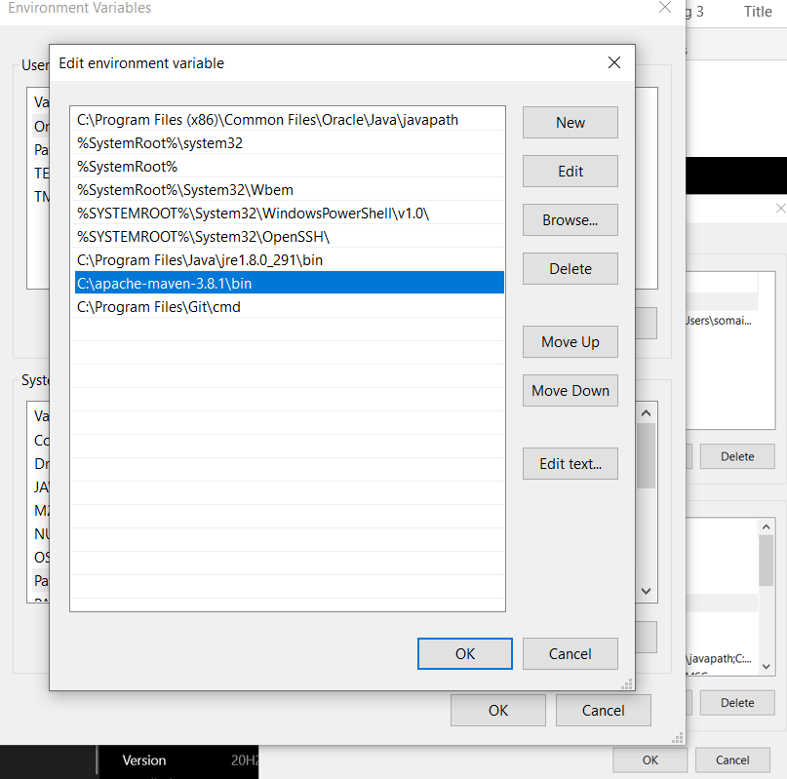

Verify Maven
Go to cmd prompt – type mvn -version

